Certificate of Completion

Michael Surdek

Southern New Hampshire University

IT 697: SQL Experiential Learning Activity

Dr. Jose Valles

May 1, 2021

**TABLE OF CONTENTS**

Experience Example…………………………………………………………….……….….….…2

Record of Hours in Experience……………………………………………………………………5

Future Application of Skill………………………………………………………………….….…6

Appendix A: Timesheets….….……………………………………………………………………7

**EXPERIENCE EXAMPLE**

One of the artifacts that I used in the Executive Brief was my pursuit of reaching the top 10 on sqlpad.io’s monthly challenge. I might not have explained it well enough in the paper, but I believe it best exemplifies what I learned as part of this experience. I wrote about this pursuit as a part of each of my reflection journals in the second half of this experience. Over the last couple of months, I was able to accumulate points in the challenge by solving 59 of the 80 questions in the movie rental problem set and I will demonstrate my work with one example that I am particularly proud of.

Each question provided instructions, contents of the relevant tables from the movie rental database, and sample results that reflect the format of the results that I must produce to obtain the correct results. The question below is to find the top customer each of the 16 movie categories. It asked me to provide each category_id and the customer_id of the customer who spent the most money renting movies from that category. To do this, I had to combine information from five tables. My query involved numerous joins, nested select queries, the MAX window function, GROUP BY, and WHERE clauses.

Instructions:

Relevant Tables:

Sample Results:

My Query:

My Results (Success):

**RECORD OF HOURS IN EXPERIENCE**

Over the ten weeks of this experiential learning activity, I engaged in 86.5 total hours of research, learning, and self-practice. This time was mostly spent learning through web and Youtube tutorials as well as attempting to write SQL queries in APEX Oracle and on sqlpad.io. Many other hours were spent engaged in the weekly discussions, reflection journals, and other resources such as podcasts and live coding streams. The end of each week usually consisted of between an hour and an hour and a half compiling my reflection journals, except for some that took more time such as in week 3. Through the first five weeks, I had spent only 38 hours on this experience, falling somewhat behind the recommended pace of 8 hours per week. In the second half of the course, I routinely spent nine or ten hours per week engaged in this experience, and in week 9 when the Executive Brief was due, I spent 15 hours which put me in a good position to exceed the 80 hours required for the experience. Most weeks, between both of my courses, I would have to work all day each Sunday. Although I would have liked to have left fewer hours of work on the days that things were due, it seemed to be unavoidable even when I spent a couple hours per day every other day of the week. Since I am going down to one course per semester again, this course has shown me the importance of getting things done early in the week and not having to worry about deadlines on Sunday.

**FUTURE APPLICATION OF SKILL**

I believe that the skills and competencies I have acquired as part of this experience will benefit me in future data analytics courses and professional opportunities. I am pursuing another experiential learning course next semester in Python. I have discovered in this experience that I will be best off if I spent the time to get ahead of the recommended pace in order to improve the quality of my reflections, overall learning, and projects later on. I also hope that what I have learned through this experience will continue to benefit me in future job opportunities. This experience has not only provided me with SQL skills that will improve my technical abilities, but it has also shown me how to effectively solve problems, maintain a drive for learning, explore new tools and technologies, and communicate well with others. In my week 4 reflection journal, I wrote about an article that I read which discusses the benefits of individuals in business roles having knowledge of programming languages and concepts, specifically R, Python, and SQL. I believe that an understanding of SQL is an essential requirement of the positions that I hope to compete for in the future, whether they will be on the business or technical side of things.

**APPENDIX A: TIMESHEETS**

Week 1

Week 2

Week 3

Week 4

Week 5

Week 6

Week 7

Week 8

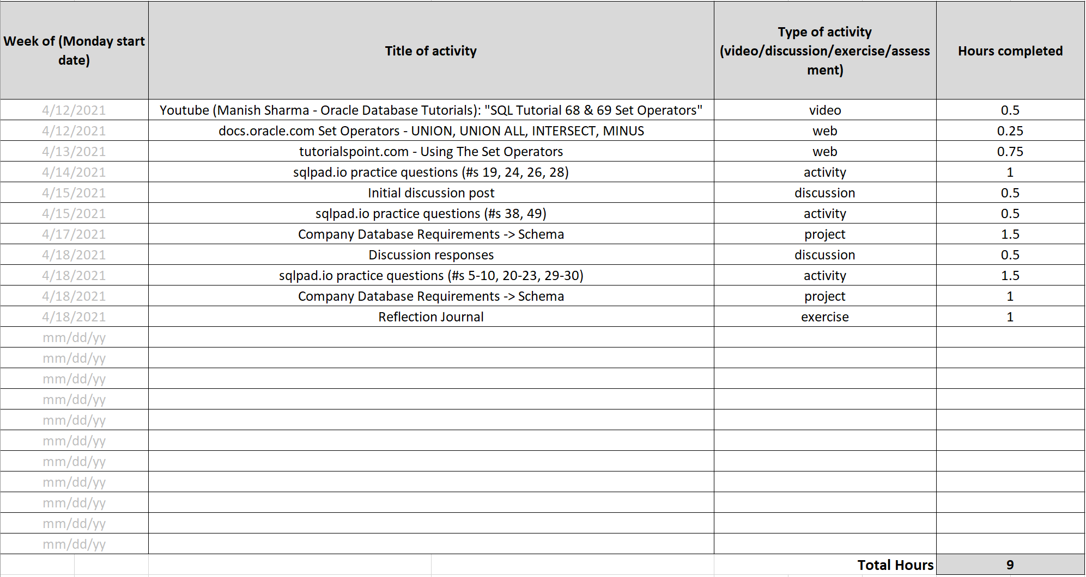

Week 9

Week 10

